Report Number: R1

**A**

**REPORT**

**ON**

**GENERAL STUDY OF 2D TRANSONIC AIRFOIL THROUGH COMPUTER SIMULATION**

**SUBMITTED BY:**

**LOKESH SILWAL**

**MECHANICAL ENGINEER**

**DEPARTMENT OF SCIENCE & HUMANITIES**

**I.O.E. PULCHOWK CAMPUS**

**KATHMANDU, NEPAL**

**SEPTEMBER 2, 2015**

Report Number: R1

**A**

**REPORT**

**ON**

**GENERAL STUDY OF 2D TRANSONIC AIRFOIL**

**SUBMITTED TO:**

**VIJAY KUMAR YADAV**

**PROFESSOR**

**SUBMITTED BY:**

**LOKESH SILWAL**

**MECHANICAL ENGINEER**

**APPROVED BY:**

**TRI RATNA BAJRACHARYA**

**DEAN, I.O.E.**

**DEPARTMENT OF SCIENCE & HUMANITIES**

**I.O.E. PULCHOWK CAMPUS**

**KATHMANDU, NEPAL**

**SEPTEMBER 2, 2015**

**LETTER OF TRANSMITTAL**

Mechanical Department

I.O.E.

Pulchowk Campus

Lalitpur

2nd September 2015

Vijay Kumar Yadav

Professor

Science and Humanities Department

I.O.E.

Lalitpur

Respected sir

I submit the accompanying report entitled “General study of 2d transonic airfoil” after completion of its simulation in simulating environment ANSYS using Spalart-Allmaras turbulent model.

The report discusses about the characteristics involved with the production of shock waves in supercritical airfoil. In this report I have made an effort to incorporate how the geometry of an airfoil effects in the production of shock waves and its effect on different factors like density,velocity.

I would like to thank Professor Sudip Bhattarai who provided me with access to his unpublished paper on Boundary layer control on an airfoil using Coanda Effect.

Yours sincerely

Er. Lokesh Silwal

Engineer

**ACKNOWLEDGEMENT**

I would like to express my sincere gratitude to all the individual who played a part to finish this report and making it a success. It would have been impossible without the help of various personalities.

I am highly indebted to Dr. Sagar Niraula, professor in MIT who provided me with datas in relation to the geometry of the airfoil.

My special thanks to Er. Piyush MIshra for his technical as well as moral support.

I am deeply thankful to Er. Amrit Singh for helping me get familiarize with the simulating software ANSYS and providing me with insight to setting up a proper simulating environment.

Finally, I am truly greatful to all those who helped in the preparation of this report.

**ABSTRACT**

This report focuses on the general study regarding transonic airfoil and production of shockwaves in it. This task was accomplished using simulating software ANSYS. The geometry of an airfoil plays an important role in generation of shock waves and this phenomenon was also studied in this report. The change in density and velocity around the airfoil due to production shock wave was also studied in this report. In general, this report focuses on the generation of shock waves for its better understanding so that necessary step can be taken to reduce as it increases drag.

**TABLE OF CONTENTS**

Letter of Transmittal ii

Acknowledgement iv

Abstract v

1. Introduction 1
2. Modeling and meshing 2
   1. Datas for airfoil

* 1. Geometry generation
  2. Mesh generation

1. Pre prossesor or boundry conditions set up

* 1. Boundary Conditions set up
  2. Material set up

* 1. Turbulent model set up

1. Result

* 1. Pressure contour
  2. Mach number contour
  3. Velocity contour

1. Conclusion
2. Recommendation
3. Reference
4. **INTRODUCTION**

A **supercritical airfoil** is an airfoil designed, primarily, to delay the onset of wave drag in the transonic speed range. Supercritical airfoils are characterized by their flattened upper surface, highly cambered (curved) aft section, and smaller leading edge radius compared with traditional airfoil shapes. The supercritical airfoils were designed in the 1960s, by then NASA engineer Richard Whitcomb, and were first tested on a modified North American T-2C Buckeye. After this first test, the airfoils were tested at higher speeds on the TF-8A Crusader. While the design was initially developed as part of the supersonic transport (SST) project at NASA, it has since been mainly applied to increase the fuel efficiency of many high subsonic aircraft. The supercritical airfoil shape is incorporated into the design of a supercritical wing.

A **shock wave** is a type of propagating disturbance. When a wave moves faster than the speed of sound in a liquid, gas or plasma (a fluid, in physics terminology) it is a shock wave. Like an ordinary wave, a shock wave carries energy, and can propagate through a medium. It is characterized by an abrupt, nearly discontinuous change in pressure, temperature and density of the medium.In supersonic flows, expansion is achieved through an expansion fan.

Shock wave is an undesirable property which increases drag of an airfoil and increases the fuel consumption. Thus many efforts has been made to reduce this property in aircrafts. But to remove the problem, we must first understand it. Thus this report focuses on understanding the nature of the shock waves.

1. **MODELING AND MESHING**

Initially 2d model was generated and meshing was done in it as per the requirement of the CFD flow simulation.

* 1. **Datas for airfoil**

For generating a 2d geometry of a transonic airfoil, the coordinates in XY system which was plotted in ICEM(meshing and modeling tool for fluid flow analysis of ANSYS CORP). Then the plotted points where joined using spline to generate the required airfoil design.

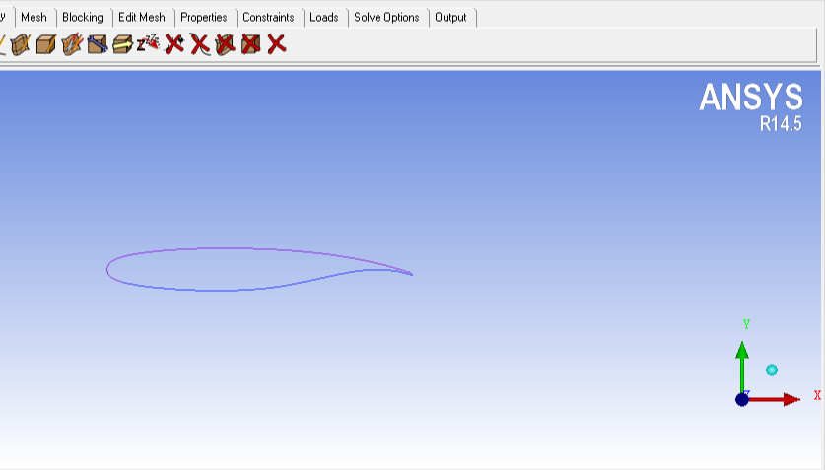

Figure shows the generated airfoil model.

* 1. **Geometry generation**

After the generation of the airfoil geometry,the complete airfoil geometry was generated. The complete geometry was generated by creating a fluid domain which was as ten times big than the geometry of the airfoil. This was carried out under assumption that the flow of fluid flowing over an airfoil doesn’t have any effect over the distant fluif domain. This assumption halps us get the better result.

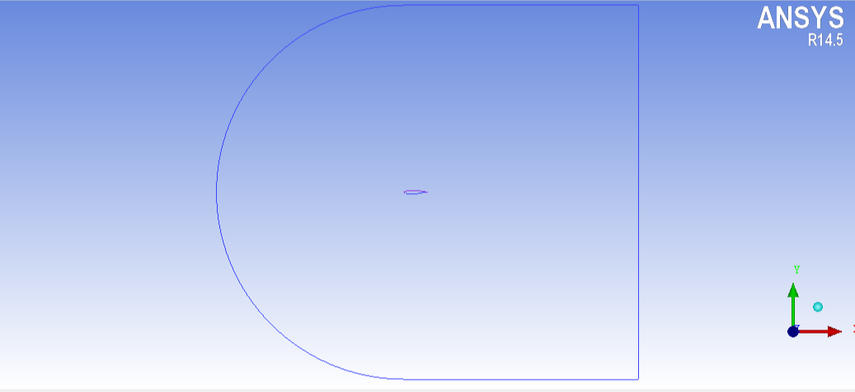

Figure above shows the diagram of the fully generated airfoil geometry in ICEM.

**2.3 Mesh generation**

After the generation of the geometry, the mesh was generated. Mesh is division of the element into finer or smaller elements so that numerical methods can be applied to calculate the unknown quantities using differential equation which are assumed to be averaged equations. Our required mesh was generated using finite element method which is most commenly used method.

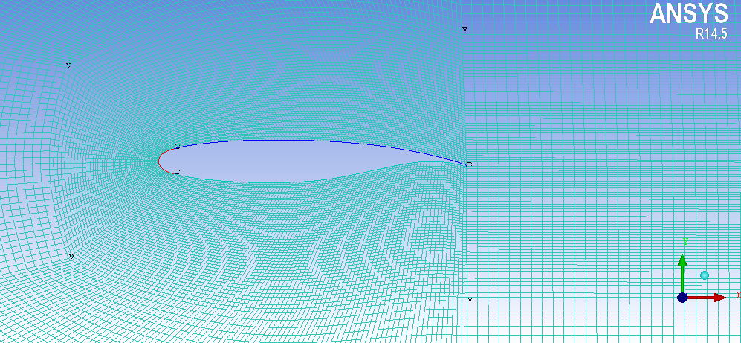

The above picture is the zoomed in view of the generated mesh which is very dense near airfoil wall as the effect is to be observed around it. Then the quality of the mesh was checked taking angle and aspect ratio as tha main factor.

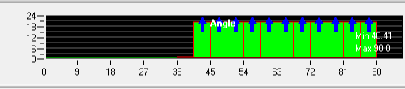

The figure shows the angle quatily of the mesh and since it was greater than 18 degree,it can be concluded that this is a proper mesh.

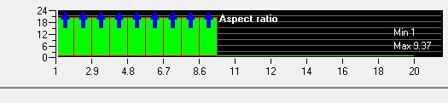

The figure shows the aspect ratio quality of the mesh and since the aspect ratio is well within 11,it can be concluded that the mesh quality is good.

1. **PRE PROCESSOR OR BOUNDARY CONDITIONS SET UP**
   1. **Boundary condition set up**

After the generation of mesh in ICEM and checking its quality,it was imported to the fluent simulating environment for simulation of fluid flow. After it was imported to fluent,boundary conditions were set up. The inlets and outlets were set up as pressure far field. The mach number was taken to be 0.8 and the temperature was taken to be ambient i.e. 300 K. the condition for 4 degree angle of attack was also set up.

* 1. **Material set up**

The default material in the simulating model is air which is also our working fluid. But the default settings were changed to account for change in density and temperature in high speed air flow. The density was made compressible which was governed by ideal gas equation. The viscosity was governed by Sutherland law which is very suitable for high speed compressible flow. The three coefficient method was used under Sutherland law. In our project, the density and viscosity are made temperature dependent but the values of thermal conductivities Cp and Cv are assumed to be constant for the simplicity of our project.

* 1. **Turbulent model set up**

The flow could not be incompressible and invisid. So the model was set up to be turbulent. And Spalart-Allmartz viscious turbulant model was choosen. The Spalart-Allmaras model is a relatively simple one-equation model that solves a modeled transport equation for the kinematic eddy (turbulent) viscosity. This embodies arelatively new class of one-equation models in which it is not necessary to calculate a length scale related to the local shear layer thickness. The Spalart-Allmaras model was designed specically for aerospace applications involving wall-bounded ows and has been shown to give good results for boundary layers subjected to adverse pressure gradients.

1. **RESULT**
   1. **Pressure contour**

After the set up,the result was runned and the obtained result was observer.the pressure contour was observed as follows.

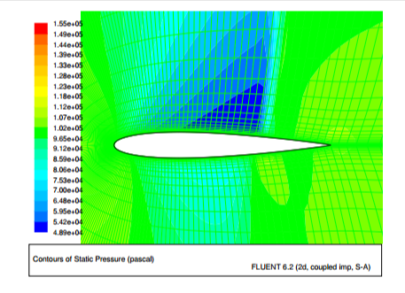

Clearly, the shock wave was obtained above the mid region of the airfoil where the pressure jumps to the high value.

* 1. **Mach number contour**

The mach number was plotted as follows.

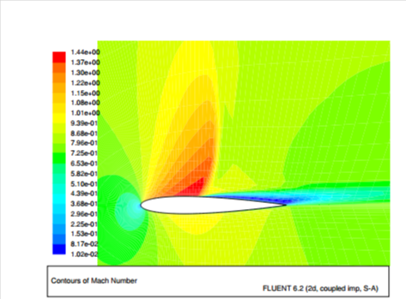

* 1. **Velocity contour**

The velocity contour in X direction was plotted as follows.

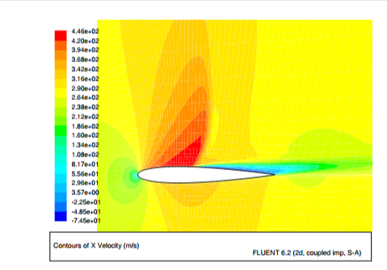

We can clearly see from the velocity contour that the velocity reaches very highly above the middle section of the airfoil indicated by the dark red lights which is the indication of generation of the shock waves.

1. **CONCLUSION**

Hence, it can be concluded that with a proper theoretical and simulating knowledge, we can set up a proper simulating environment for its different study. In this report, we used our knowledge to set up simulating environment for transonic airfoil for observing the shock wave generation and our result was also acceptable.

It can also be observed that with todays technology,it is almost impossible to avoid the shock waves in high speed compressible flows but it can be reduced and many efforts are being made to better understand this phenomenon.

1. **RECOMMENDATIONS**

After the detail study transonic airfoil, I would like to make following recommendations:

1. It is better to use K-epsilon turbulating model rather than Spalart-Allmartz turbulating model for more accurate result
2. It is also good practice to vary thermal constants with temperature rather than keeping it fixed.
3. More finer mesh should be generated for more accurate result
4. Geometry optimization of the airfoil can be donr to reduce the produced shock waves
5. **REFERENCES**
6. Fox, Philip J. Fluid Mechanics. New Delhi: McGraw Hill Education (India) Private Limited.1993.
7. Johnstone, Wilfred. A Detail Study on Aerodynamics. Washington: McGraw Hill Education (USA) Private Limited. 2002.